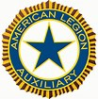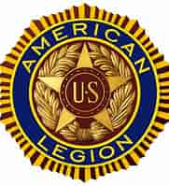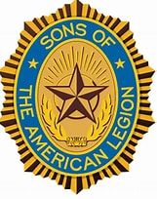
American Legion Post 315 Golf Scramble
Saturday, August 20, 2022
Registration 7:30 am 9:00 am Shotgun
Hills’ Heart of the Lakes Golf Course
500 Case Road, Brooklyn, MI 49230

$80 a person - $320 per 4-some (All Welcome)
4 Person Scramble
Includes 18 holes, cart, hot dog at the Turn
50/50 & Skins
Taco Bar at the American Legion following golf
Wilber-Bartlett Post 315
211 Chicago Street, Brooklyn, MI 49230

Proceeds go to the American Legion Ritual Team
and Local Veterans
Hole Sponsorship $100 - Sign w/Name or Business at a hole
For more information or RSVP contact Lori Booth-517-474-2097 or Scott Elliott 734-474-2714
******************************************************************
Mail in payment by August 1, 2022 payable to American Legion Auxiliary Unit 315 to:
Lori Booth, 3141 Matthews St, Jackson, MI 49203
Team Members: Captain w/phone

