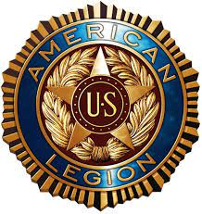 From the Desk of the Commander:
All,
I want to welcome you to the American Legion Post 315 Web Site!!! One of the goals that I had when I took over as Commander was to improve communications. Given our large and diverse group, I believed that a web site would the best vehicle to get our message across and to keep members and visitors informed. Some of the pages you will find on the site will include:
- Contact Us which will provide contact information for the Post, Units and Services such as the Ritual Team and Chaplain. In addition, a map to the Post.
- Post Calendar which will provide an annual calendar to make it easier to for you to plan in the future.
- Legion Info which will provide:
  - Commander’s letters in chronological order.
  - Post Board Meeting slides
  - Post Committee Meeting slides
  - Post Membership slides
  - Financial report
- SAL Info which will provide information concerning the Sons of American Legion.
- Auxiliary Info which will provide information concerning the Legion Auxiliary.
- Ritual team which will provide information concerning the Post Ritual Team to include photos.
- Chaplain’s Corner with information on both sick members and those who have passed along with spiritual guidance.
- Bar where you find information concerning the latest specials and any events managed by the bar and occurring at the post
- Service officer will be the biggest page, content wise, at the Post. Information concerning VA benefits, State benefits, claims assistance, How To’s and Veteran’s assistance will be located here.
As a member or visitor, I encourage you to utilize this web site to its fullest extent. Make sure your fellow members know where to find us on the web and encourage them to use the site also.
We encourage feedback from members to improve the site so please do not hesitate to tell us what you want to see and how you want to see it. Any of the three Unit Commanders/President will be happy for the input.

Mark Young
Commander
American legion Post 315

